**News From**

**Lutherville Lab Elementary School**

1700 York Road, Lutherville, MD 21093

410. 887.7800

***November 2019***

Mrs. Bissell, Principal

Ms. Owens & Ms. Hart, Assistant Principals

**Message from Mrs. Bissell**

Lutherville Families,

We are excited to welcome parents to Lutherville next week during American Education Week. Visitation is from 9:00 am to 12:00pm. We will have volunteer training during this week, as well as support to sign up for BCPS One. The schedule for visitation is as follows:

* ***Monday, November 18th –Fifth Grade***
* ***Tuesday, November 19th – First & Fourth Grades***
* ***Wednesday, November 20th – Kindergarten & Second Grades***
* ***Thursday, November 21th – Third Grade***

Report cards will be sent home Thursday, November 21st. During the first quarter, Report cards will not include comments and special area grades. Conference day is Friday, November 22, 2019. Please email or call your child’s teacher to set up a conference time.

Sincerely,

Mrs. Bissell

**Upcoming Dates**



**November 18th** Visit from WBAL to present **Ravens Incentive Cinch Bags, 9:30am**

**November 18-21st** American Education Week

**November 19th**  Board of Education Meeting, Greenwood-Building E, 6:30 p.m.

**November 21st**  Distribution of Report Cards

**November 22nd** Elementary Conference Day, Schools Closed for Elementary Students



[This Photo](http://blogs.ubc.ca/knowyourstatus/page/2/) by Unknown Author is licensed under [CC BY-NC-ND](https://creativecommons.org/licenses/by-nc-nd/3.0/)

**November 28-29th** Thanksgiving Holiday, Schools Closed



**December 3rd ­** Board of Education Meeting, Greenwood-Building E, 6:30 p.m.

**December 5th** PTA Meeting, 6:00-7:30 p.m.

**December 11th** Parent Information **School Climate at Lutherville**, 6:00-7:00 p.m.

**December 13th**  Winter Wear Spirit Day

**December 17th**  Board of Education Meeting, Greenwood-Building E, 6:30 p.m.

**December 23rd-January 1st** Schools Closed, Winter Break

**January 2nd** - Schools Reopen after Winter Break

**Virtue of the Month-Flexibility**

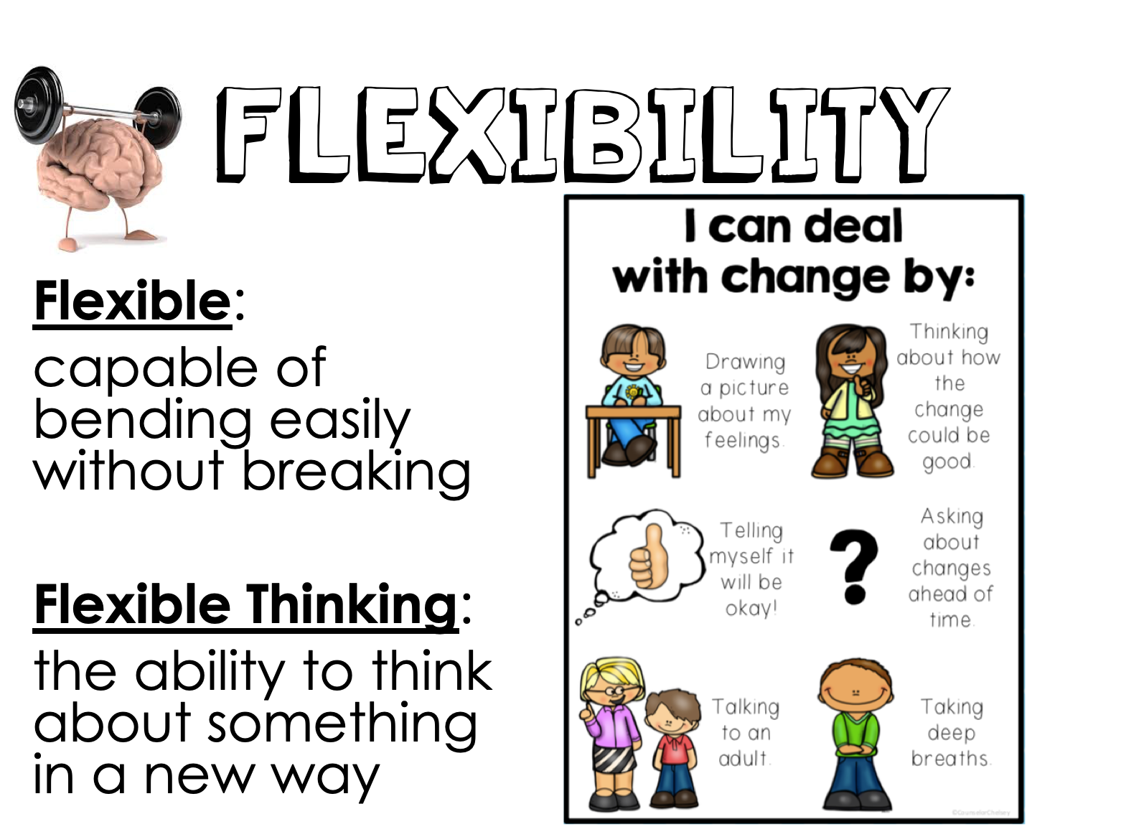

**Helpful books**: Beautiful Oops by Barney Saltzberg

My Day Is Ruined!: A Story Teaching Flexible Thinking by Bryan Smith

**News from the School Counselor**

It is hard to believe that the holidays are quickly approaching. For Lutherville Lab, it is a time to remember boys and girls that need our help. We are continuing our tradition of the **Mitten Tree**. We will collect **new** mittens, hats, gloves, and scarves to decorate our tree in the lobby. These will be donated to the shelters in our area and all sizes are appreciated.

We will also be collecting toys for children through Kids Helping Hopkins. We will be collecting **new** unwrapped toys. Please consider sending in items for the Mitten Tree or a toy for Kids Helping Hopkins. Please do not send in plush toys or stuffed animals. Our children have gained so much from the experience of giving to others so we hope that you will consider donating again. These drives will take place from Monday, December 2nd- Friday, December 13th. Thank you so much in advance for your donations.

**Information from the Office**

***Early Dismissals*** *–* Please send a note in the morning with your student if you are planning on picking them up early. If you email the homeroom teacher about an early dismissal, please include Ms. Mills at [tmills2@bcps.org](mailto:tmills2@bcps.org) or Mrs. Wingerd at [dwingerd@bcps.org](mailto:dwingerd@bcps.org) in that email. This will afford us the opportunity to know where your child is when you come to get her/him. Please note that no student will be called to the office until a parent/guardian has arrived and signed the student out. ***After 3:30 p.m., we will not be***

***able to dismiss students*** from school as teachers and students are preparing for the end of the day and dismissal procedures.

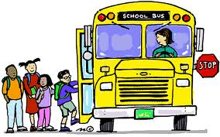***Bus Loop –*** Please do not enter the bus loop or the first entrance during arrival and dismissal. It creates a safety concern when cars are passing buses as students are unloading/loading. The bus loop and the first entrance are closed from 8:45 a.m. to 9:10 a.m. and 3:40 p.m. to 4:10 p.m. If you need to visit the school, please park in the parking lot adjacent to the car dealership. If you have any questions, please call the school at 410.887.7800.

***Field Trips*** – Information about paying on-line for field trips will be coming home with your student when it is time for their first field trip. Please consider paying on line so that students do not carry money to school taking a chance that they will lose it.

***Emergency Contact Forms*** – It is extremely important that we have accurate contact information for every child. Please remember to contact your child’s teacher and the main office, **in writing**, if changes need to be made.

***Parking*** - School is now in session, so please be mindful when parking in the surrounding neighborhood, primarily Division Avenue. Most residents do not have driveways and much of the street near the school is posted no parking and when we park in posted “no parking” spaces the residents are unable to get near their home to park. Thank you in advance for your consideration.

************************************************************************************

**Young Authors’ Writing Contest**: Entries Due December 2nd

**Calling all Young Authors!**

The Baltimore County Reading Association is looking for short stories or poems submitted by our students in grades 1-5! For the first time, first graders are also invited to participate!

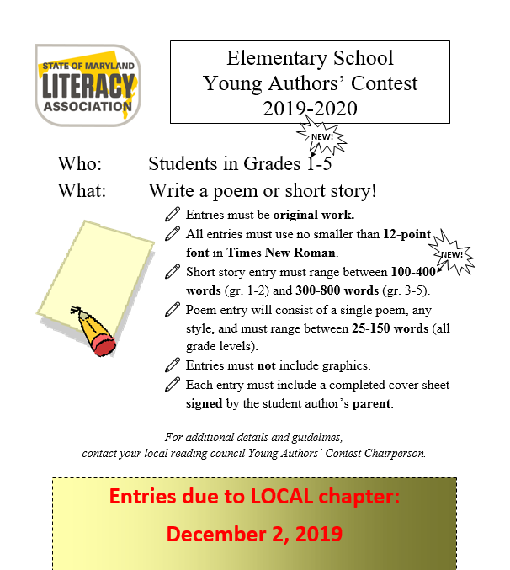

**New this year!! Lutherville Lab will be pairing the Young Authors’ Contest with an author visit. Author Mark Gruber-Lebowitz and illustrator, Sheldon Gruber-Lebowitz have written three books. They will be sharing their motivation for writing and illustrating their newest book, *In Search of Heroes.***

**Lutherville has the privilege of hosting two assemblies with the authors and a luncheon for selected students who participate in the Young Authors’ Writing contest.**

**Their recent book, *In Search of Heroes,* will be available to purchase in advance and have autographed by the authors.**

***In Search of Heroes,* details the everyday heroes in the lives of children and their importance. It is a wonderful story. More information about the assembly will be coming home soon!**

All students are encouraged to participate. If students in kindergarten would like to participate, we welcome them to participate and will recognize them at Lutherville. Kindergarten students may write very short stories about *heroes* to include in our in-house contest.

Classroom teachers have entry forms. If you have any questions, please reach out to Mrs. Henderson, Reading Specialist, at [jhenderson@bcps.org](mailto:jhenderson@bcps.org) for help.

We look forward to reading all entries! Happy writing!